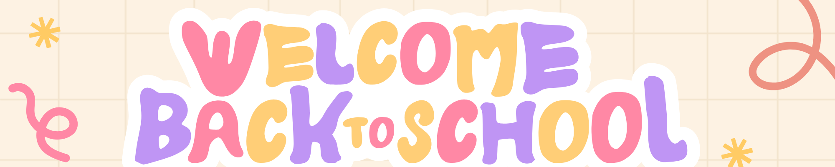

Dear Class 2 Families,
A very warm welcome back to school after the half-term break!
We hope you all had a wonderful two weeks, full of rest, fun and special memories. This is always such a lovely half term as we begin to think about Christmas and enjoy all the excitement leading up to the big day!

Water Bottles, Snacks and Uniform
Please make sure your child brings a labelled water bottle to school each Monday — we’ll send it home on Fridays. Each child is given one piece of fruit for a morning snack, but we ask that you also pack an extra fruit or veggie snack for the afternoon.
Please also ensure all jumpers, fleeces and cardigans are clearly labelled. The weather can be unpredictable, so your child should have a coat each day — even if it looks sunny in the morning!

PE Days and Homework
PE will take place on Thursdays and Fridays, so please send your child to school in their PE kit on those days.
For homework this half term, our main focus is reading. Please read with your child as often as possible. RWI reading books will be changed on Fridays. Children following the RWI programme will also have Speedy Green Words and Red Words to practise — these will be in their reading diary. A few minutes of practice each evening really makes a big difference!
We will also be sending home spelling and maths homework for Year 2 children (and for any Year 1s who would like it) on alternate weeks.

Topic: Paws, Claws and Whiskers
As part of our topic this half term, we’ll be inviting the children to bring in their pets for a short visit! A sign-up sheet will be available soon.
We know that some children can feel nervous around animals, so we’ll make sure everyone feels safe and comfortable. If your child has any pet-related allergies that we may not already know about, please let us know.

Parent Helpers
If you (or grandparents or other family members) have any spare time and would like to come in to listen to readers, we would love your help! Please speak to us if you’re interested.

Show and Tell Fridays & Barnaby Bear
A huge thank you to everyone who has taken Barnaby Bear on your family adventures — the children have loved sharing his travels in class!
Show and Tell has also been a big success. This half term, however, we’re encouraging the children to bring in something a bit more extraordinary — perhaps something linked to our topic, or something special to them — rather than toys, keyrings, or playground treasures!

Looking Ahead
Last half term was fantastic — the children settled beautifully, and we’re so proud of how they’ve started the year. This half term, our focus will be on showing they are ready to learn and working on less fussing during transitions and routines.
As always, if you have any questions (big or small), please catch us at the gate after school, contact the office to arrange a meeting, or drop us an email.
Warm regards,
The Class 2 Team

